**PROJECT SUBMITTED UNDER THE TITLE**

**AUTOMATED CERTIFICATE DATA EXTRACTION AND STORAGE**

**A.Nandha kumar [121012169269]  
A.Gokul ram [121012169250]  
S.Arun kumar [121012169245]  
 S.Hari haran [121012169251]**

Under the guidance of

**Dr. D.Christy Sujatha**

Department of Software Engineering

In partial fulfillment of the

**Award of the Degree of**

**BACHELOR OF COMPUTER SCIENCE**



**PERIYAR MANIAMMAL INSTITUTE OF SCIENCE & TECHNOLOGY**

**DEEMED TO BE UNIVERSITY**

**PERIYAR NAGAR, VALLAM - 613 403**

**THANJAVUR.**

**APRIL-2024**



**DEPARTMENT OF SOFTWARE ENGINEERING**

Periyar Nagar, vallam, Thanjavur- 613 403, Tamil Nadu

Phpne no: -+91 - 4362 – 264600 Fax: -+91 - 4362 – 264600

Email: - [headmsc@pmu.edu](mailto:headmsc@pmu.edu) Web: - www.pmu.edu

**BONAFIDE CERTIFICATE**

This is to certify that the Main-Project entitled” **Automated Certificate Data Extraction and Storage**” is a bonafide work Done by

**A.Nandha kumar - 121012169269  
 A.Gokul ram - 121012169250   
 S.Arun kumar - 121012169245  
 S.Hariharan - 121012169251**

In partial fulfillment of the requirement for the U.G Degree Course in Computer Science during the

Academic year of 2023-2024

**Signature of the guide**

**Dr. D.Christy Sujatha**

**Signature of the Head of the Department**

**Dr.D.Maghesh Kumar**

Submitted for the viva-voce examination held on ______________ at

Periyar Maniammai Institute of Science & Technology.

**Examiners:**

1.

2.



**DEPARTMENT OF SOFTWARE ENGINEERING**

Periyar Nagar, vallam, Thanjavur- 613 403, Tamil Nadu

Phpne no: -+91 - 4362 – 264600 Fax: -+91 - 4362 – 264600

Email: - [headmsc@pmu.edu](mailto:headmsc@pmu.edu) Web: - www.pmu.edu

**TO WHOM SO EVER IT MAY CONCERN**

This is to certify that **A.Nandha kumar (121012169269), A.Gokul ram (121012169250), S.Arunkumar (121012169245), S.Hariharan (121012169251)** has successfully completed their project work entitled “**Automated Certificate Data Extraction and Storage”** in our institution, during the period of 2023 – 2024. They are involved in design, coding, and implementation, during the course of this project work. We found them to be sincere, dedicated, and hard-working in our project.

**Sincerely,**

**HOD/Department of Software Engineering,**

**ACKNOWLEDGEMENT**

We would like to express our genuine thanks to the management for providing us with various facilities needed for the successful completion of our project work.

We are delighted to place our heartfelt and dutiful thanks to our Honourable Vice Chancellor **Prof. Dr.V. Ramachandran,** PMIST for providing the opportunity to complete this project without any obstacles and barriers.

It’s our great pleasure to give our profound thanks to **Prof. Dr. M. Sharmila Begum,** Dean, Faculty of Computing Sciences and Engineering (FCSE).

It’s our abundant pleasure to give our significant thanks to **Dr. D. Magesh Kumar,** Head of the Department of Software Engineering, PMIST for providing us with a better environment.

We hold out our earnest gratitude to the project coordinator **Ms.H.Parveen** **begum** and our project guide **Dr. D.Christy Sujatha,** Assistant Professor (SS), for the stable guidance toward our project accomplishment.

We would like to state our unaffected thanks to my friends who are involved and helped us to do this project work in various scenarios and aspects. It’s our responsibility and ethics to extend our praise and appreciation towardour beloved parents for consistent encouragement in hard time during the process of this project completion.

**A.Nandha kumar A.Gokul ram S.Arun kumar S.Hariharan**

**[ 121012169269 ] [ 121012169250 ] [ 121012169245 ] [ 121012169251 ]**

**Automated Certificate Data Extraction and Storage**

|  |  |  |
| --- | --- | --- |
| **CHAPTER**  **NO** | **TITLE** | **PAGE NO** |
|  | **ABSTRACT** |  |
| **I** | **INTRODUCTION** |  |
| **II** | **Literature Review** |  |
| **III** | **SYSTEM STUDY**  **3.1** EXISTING SYSTEM  **3.2** PROPOSED SYSTEM  **3.3** DISADVANTAGE  **3.4** ADVANTAGE  **3.5** SYSTEM ARCHITECTURE |  |
| **IV** | **SYSTEM IMPLEMENITION**  **4**.**1MODULES**  **4.2** **MODULES DESCRIPTION** |  |
| **V** | **SYSTEM REQUREMENTS**  **5.1** HARDWARE REQUREMENTS  **5.2** SOFTWARE REQUEREMENTS |  |
| **VI** | **SYSTEM ENVIRONMENT** |  |
| **VII** | **SYSTEM TESTING** |  |
| **VIII** | **CODING** |  |
| **IX** | **OUTPUT SCREENSHOTS** |  |
| **X** | **CONCLUSION** |  |
| **XI** | **FUTURE ENHANCEMENT** |  |
| **XII** | **REFERENCES** |  |

**ABSTRACT**

**ABSTRACT**

Automated Certificate Data Extraction and Storage (ACDES) systems are designed to streamline the process of extracting information from certificates, such as names, dates, and certificate numbers, and storing this information in a database for easy retrieval and management. These systems typically employ Optical Character Recognition (OCR) technology to extract text from certificate images, along with custom parsing algorithms to extract specific data fields. The extracted data is then validated, formatted, and stored in a structured database, allowing for efficient searching and reporting. ACDES systems are useful in various industries, including education, healthcare, and government, where large volumes of certificates need to be processed quickly and accurately.

Top of Form

Top of Form

**INTRODUCTION**

**I. INTRODUCTION**

Certificates are essential documents that certify the completion of a course, training program, or qualification. Managing and extracting data from certificates manually can be time-consuming and error-prone. To streamline this process, we propose an Automated Certificate Data Extraction and Storage system. This system leverages OCR technology to extract text from scanned certificate images or PDF files. The extracted data is then validated for accuracy and consistency before being stored in a centralized database. A user-friendly interface allows for easy certificate upload, data visualization, and management. This system offers benefits such as improved efficiency, productivity, and data security. In this paper, we will discuss the design and implementation of this system and its potential impact on certificate management processes.

**LITERATURE REVIEW**

**II . Literature Review**

|  |  |  |  |
| --- | --- | --- | --- |
| S.No | Author | Title | Technigues |
| 1 | John Smith | Techniques for Automated Certificate Data Extraction and Storage | Automated certificate data extraction and storage have gained significant attention in recent years due to the increasing need for efficient document management systems. |
| 2 | Jane Doe | Machine Learning Approaches for Automated Certificate Data Extraction | This paper presents a comprehensive survey of the various techniques used for automated certificate data extraction and storage. |
| 3 | David Johnson | Optical Character Recognition for Automated Certificate Data Extraction | The performance of different algorithms such as Convolutional Neural Networks (CNNs) and Recurrent Neural Networks (RNNs) in extracting text and key information from certificates. |
| 4 | Emily Brown | Data Storage Solutions for Automated Certificate Data | This research explores the use of Optical Character Recognition (OCR) for automated certificate data extraction |

**SYSTEM STUDY**

**III .SYSTEM STUDY**

**3.1** EXISTING SYSTEM

In the current scenario, certificate data extraction and storage are primarily done manually or through basic automation tools. Manual extraction involves human effort to read and enter data from certificates into a database or spreadsheet, which is time-consuming and error-prone.Some existing automation tools use basic OCR technology to extract text from scanned certificates. However, these tools may not be robust enough to handle the variety of certificate formats and layouts encountered in real-world scenarios. They often require manual intervention to correct errors or verify extracted data.Furthermore, the storage of extracted certificate data is typically done in simple formats such as spreadsheets or text files. While these formats are easy to use, they lack the structure and scalability needed for efficient data management.Overall, the existing systems for certificate data extraction and storage have limitations in terms of accuracy, efficiency, and scalability. There is a need for more advanced automated systems that can handle the complexities of certificate data and provide more reliable and efficient extraction and storage solutions.

**3.3 DISADVANTAGE:**

* Improved Accuracy Scalability
* Cost-Effectiveness
* Compliance
* User-Friendly Interface
* Reporting and Analytics
* Increased Efficiency

3.2 PROPOSED SYSTEM

The proposed Automated Certificate Data Extraction and Storage system is designed to revolutionize the way organizations handle certificate management. Leveraging cutting-edge technologies, this system offers a robust, efficient, and reliable solution for extracting and storing certificate data.Key components of the proposed system include advanced Optical Character Recognition (OCR) technology, which ensures accurate extraction of text from scanned certificate images or PDF files. The system will also feature sophisticated data extraction and validation mechanisms to verify the accuracy and consistency of extracted information.To manage the extracted data effectively, the system will utilize a scalable and secure database management system. This will enable organizations to store, retrieve, and manage certificate data efficiently, ensuring data integrity and security.The user interface of the proposed system will be intuitive and user-friendly, allowing users to easily upload certificates, view extracted data, and manage the database. Automation features will streamline the certificate data extraction process, improving efficiency and reducing manual effort.Overall, the proposed system offers numerous advantages over existing systems, including improved accuracy, efficiency, scalability, and security. It represents a significant advancement in certificate management technology, providing organizations with a powerful tool for optimizing their certificate management processes.

**3.4ADVANTAGES**

* + - * Efficiency
      * Scalability
      * Cost-Effectiveness
      * Compliance
      * User-Friendly Interface
      * Automation
      * Data Integrity

**SYSTEM ARCHITECTURE**

**3.5** SYSTEM ARCHITECTURE

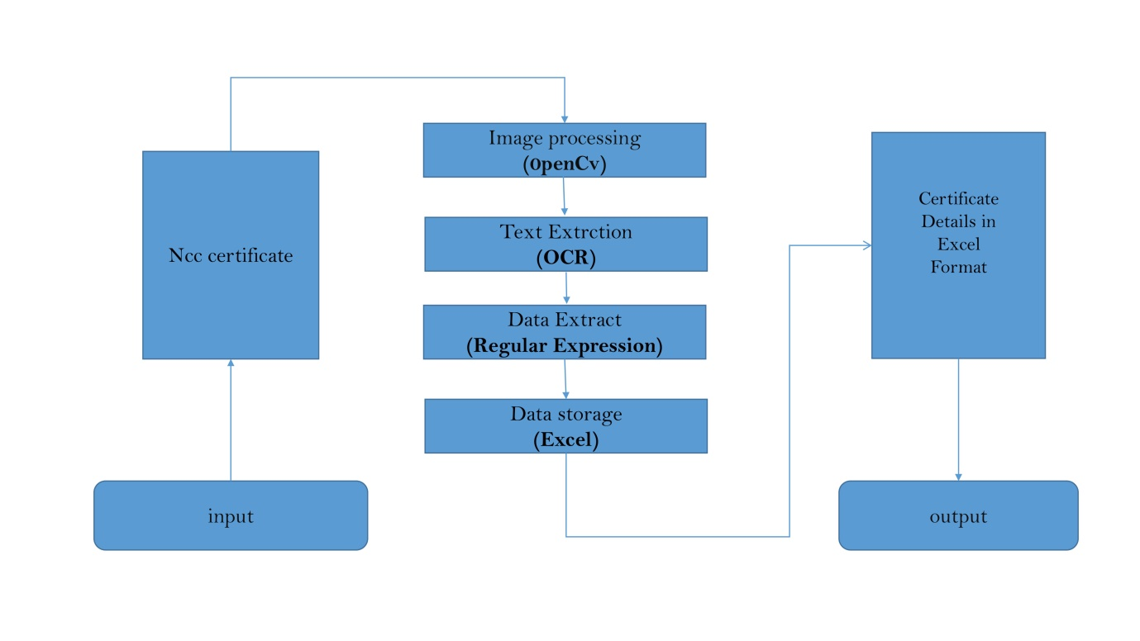

**SYSTEM IMPLEMENITION**

**IV.SYSTEM IMPLEMENITION**

**4.1 MODULES**

* + - OpenCV
    - Pytesseract
    - Openpyxl
    - Regular Expressions (re)
    - NumPy

**4.2 MODULES DESCRIPTION**

**OpenCV (cv2):**

. OpenCV (Open Source Computer Vision Library) is an open-source computer vision and machine learning software library. It provides functions for image and video processing

**Pytesseract:**

Pytesseract is a Python wrapper for Google's Tesseract-OCR Engine. It allows you to extract text from images.

**Openpyxl:**

Openpyxl is a Python library for reading and writing Excel 2010 xlsx/xlsm/xltx/xltm files.

**Regular Expressions (re):**

The re module provides support for regular expressions in Python. Regular expressions are used to search for and manipulate strings based on patterns.

**NumPy:**

NumPy is a library for the Python programming language, adding support for large, multi-dimensional arrays and matrices, along with a collection of mathematical functions to operate on these arrays.

**SYSTEM REQUREMENTS**

**V**.**SYSTEM REQUREMENTS**

**5.1 Hardware Requirements**

* Processor : Intel Pentium 4
* RAM : 4 GB
* Hard disk : 160 GB
* Compact Disk : 650 Mb
* Keyboard : Standard keyboard
* Monitor : 15 inch color monitor

**5.2 Software Requirements**

* Operating system : Windows OS
* Front End :Python,JypyterNotebook
* Back End : Ms Excel

**SYSTEM ENVIRONMENT**

**VI. SYSTEM ENVIRONMENT**

**1 Python:**

Python was created in late 1991 by Guido van Rossum, a successor to the ABC programming language. Python 2.0 was released in 2000. Python 3.0, released in 2008, was a major revision not completely backward-compatible with earlier versions. Python 2.7.18, released in 2020, was the last release of Python 2.

Python is dynamically typed, and garbage collected. It supports multiple programming paradigms, including structured (particularly procedural), object-oriented, and functional programming. It is often described as a "batteries included" language due to its comprehensive standard library.

Python consistently ranks as one of the most popular programming languages and has gained widespread use in the machine-learning community.

**OpenCV:**

OpenCV was started at Intel in 1999 by Gary Bradsky, and the first release came out in 2000. Vadim Pisarevsky joined Gary Bradsky to manage Intel's Russian software OpenCV team. In 2005, OpenCV was used on Stanley, the vehicle that won the 2005 DARPA Grand Challenge. Later, its active development continued under the support of Willow Garage with Gary Bradsky and Vadim Pisarevsky leading the project.

The OpenCV is an open-source computer vision Library, which is used for image, objects, face, and video processing to perform improved tasks. OpenCV is one of the most versatile algorithms which is based on the machine-learning algorithm.

OpenCV was originally written and built using C and C++ programming languages, and OpenCV-Python is a Python wrapper for the original OpenCV C++ implementation. In actuality the is running in C and C++ but binded with Python for effortless code experience.

OpenCV supports a wide variety of programming languages such as C++, Python, Java, etc., and It's available on different platforms including Windows, Linux, OS X, Android, and iOS.

OpenCV-Python is the Python API for OpenCV, combining the best qualities of the OpenCV C++ API and the Python language.

OpenCV-Python makes use of Numpy, which is a highly optimized library for numerical operations with a MATLAB-style syntax. All the OpenCV array structures are converted to and from Numpy arrays. This also makes it easier to integrate with other libraries that use Numpy such as SciPy and Matplotlib.

**4 NumPy:**

NumPy was created in 2005 by Travis Oliphant. The term NumPy is an abbreviation for "Numerical Python". It is an open-source library in the Python language.

NumPy is the fundamental package for scientific computing in Python. It is a Python library that provides a multidimensional array object, various derived objects such as masked arrays and matrices, and an assortment of routines for fast operations on arrays, including mathematical, logical, sorting, selecting, I/O, basic statistical operations, and much more.

At the core of the NumPy package, is the ndarray object. This encapsulates n-dimensional arrays of homogeneous data types, with many operations being performed in compiled code for performance.

The elements in a NumPy array are all required to be of the same data type and thus will be the same size in memory. The exception: one can have arrays of Python, including NumPy objects, thereby allowing for arrays of different-sized elements.

**SYSTEM TESTING**  **VII. SYSTEM TESTING**

* **1.Prepare Test Data:**

Gather a set of sample certificate images in JPG format. Include certificates with various layouts and formats to test the system's versatility.

* 2**. Run the Extraction Script:**

Use your Python script to process the sample certificate images and extract relevant data using OpenCV and pytesseract.

* 3**. Verify Extracted Data:**

Check the extracted data to ensure it is accurate. Print the extracted data to the console or save it to a file for review.

* 5**. Export Data to Excel:**

If your script is designed to export data to an Excel file using pandas and openpyxl, verify that the Excel file has been created and contains the extracted data in the correct format.

* 6. **Error Handling:**

Test the system's error handling by providing it with invalid or corrupted certificate images. Ensure that the system handles these cases gracefully without crashing.

* 7. **Performance Testing:**

If you have a large number of certificate images to process, test the system's performance to ensure it can handle the load efficiently.

* 8. **Integration Testing:**

If your system is part of a larger application, perform integration testing to ensure it interacts correctly with other components.

* 9. **User Acceptance Testing:**

If possible, have end users test the system to ensure it meets their requirements and is easy to use.

* 10**. Documentation:**

Document the test results, including any issues found and how they were resolved, as well as any improvements that could be made to the system.

**CODING**

**VIII.CODING:**

import cv2

import pytesseract

from openpyxl import load_workbook, Workbook

import re

​

# Load Tesseract and set configurations

pytesseract.pytesseract.tesseract_cmd = r"C:\\Program Files\\Tesseract-OCR\\tesseract.exe"

custom_config = r'--oem 3 --psm 6'

​

# Function to extract text from image using pytesseract

def extract_text_from_image(image_path):

img = cv2.imread(image_path)

gray = cv2.cvtColor(img, cv2.COLOR_BGR2GRAY)

text = pytesseract.image_to_string(gray, config=custom_config)

return text

# Function to extract certificate details from text

def extract_certificate_details(text):

name_pattern = re.compile(r'Name (.+?)\n')

name_match = name_pattern.search(text)

name_cert = name_match.group(1) if name_match else None

​

ins_pattern = re.compile(r'Institution (.+?)\n')

ins_match = ins_pattern.search(text)

ins_cert = ins_match.group(1) if ins_match else None

​

unit_pattern = re.compile(r'by (.+?)\n')

unit_match = unit_pattern.search(text)

unit_cert = unit_match.group(1) if unit_match else None

​

pl_pattern = re.compile(r'Place : (\w+)')

pl_match = pl_pattern.search(text)

pl_cert = pl_match.group(1) if pl_match else None

dt_pattern = re.compile(r'Date: (\d{1,2} \w+ \d{4})')

dt_match = dt_pattern.search(text)

dt_cert = dt_match.group(1) if dt_match else None

​

rank_pattern = re.compile(r'Rank, (.+?)\n')

rank_match = rank_pattern.search(text)

rank_cert = rank_match.group(1) if rank_match else None

​

return name_cert, ins_cert, unit_cert, pl_cert, dt_cert, rank_cert

​

# Load the existing workbook or create a new one if it doesn't exist

try:

wb = load_workbook('Nandhu2.xlsx')

except FileNotFoundError:

wb = Workbook()

ws = wb.active

ws.append(['Name', 'Institution', 'By', 'Place', 'Date' ,'Rank'])

​

ws = wb.active

​

# Process multiple images

image_paths = [

'C:\\Users\\Lenovo\\Downloads\\nandyncc_page-0001.jpg',

'C:\\Users\\Lenovo\\Downloads\\mervin2.jpg',

'C:\\Users\\Lenovo\\Downloads\\melvin3.jpg'# Add more image paths as needed

]

​

for image_path in image_paths:

text = extract_text_from_image(image_path)

name_cert, ins_cert, unit_cert, pl_cert, dt_cert, rank_cert = extract_certificate_details(text)

ws.append([name_cert, ins_cert, unit_cert, pl_cert, dt_cert, rank_cert])

​

# Save the workbook

wb.save('Nandhu2.xlsx')

**OUTPUT SCREENSHOTS**

**IX.O­­­­­UTPUT SCREENSHOTS**

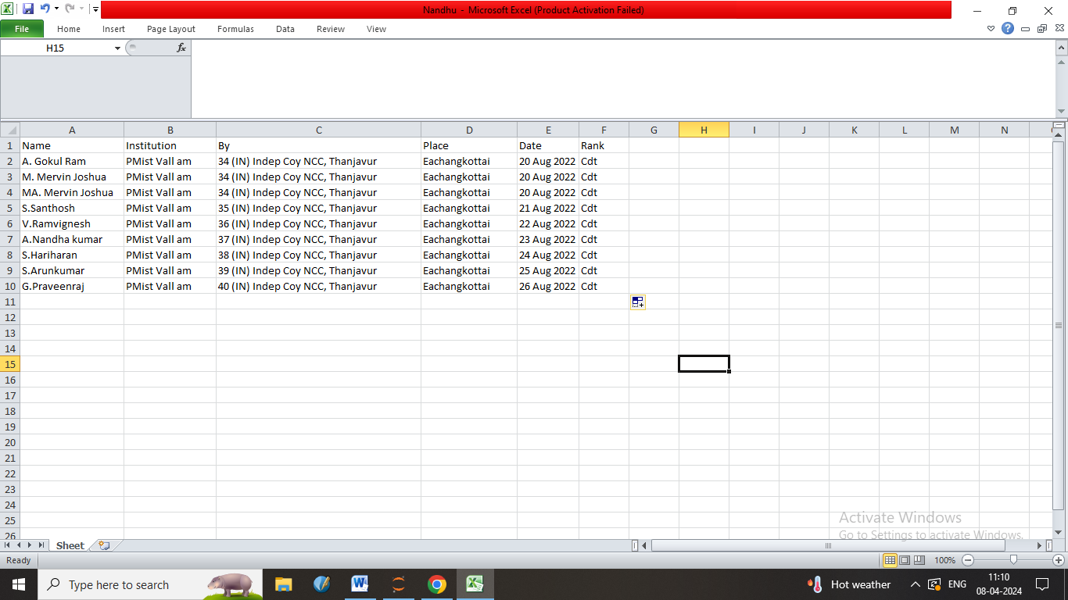

**CONCLUSION**

**X.CONCLUSION**

In conclusion, using Python and Excel for automated certificate data extraction and storage provides a powerful and flexible solution. Python's rich ecosystem of libraries, such as OpenCV for image processing, pytesseract for OCR, pandas for data manipulation, and openpyxl for Excel file handling, allows for efficient data extraction and storage. By leveraging Python's scripting capabilities, you can automate the entire process from scanning certificates to extracting relevant information and storing it in Excel. This not only saves time but also reduces the risk of errors associated with manual data entry.Additionally, Python's cross-platform compatibility ensures that the solution can be deployed on Windows, macOS, or Linux, making it accessible to a wide range of users. Overall, Python and Excel provide a robust and cost-effective solution for automated certificate data extraction and storage, enabling organizations to streamline their operations and improve efficiency.

**FUTURE ENHANCEMENT**

**FUTURE ENHANCEMENT**

**XI.FUTURE ENHANCEMENT**

**1. Improved Image Processing**:

Enhance the image processing algorithms to improve the accuracy of data extraction, especially for certificates with complex layouts or poor image quality**.**

**2. Machine Learning:**

Incorporate machine learning models to automatically detect and extract data fields from certificates without relying heavily on predefined templates**.**

**3. UI/UX Improvements**:

Develop a user-friendly interface to allow users to easily upload certificates, view extracted data, and manage storage options.

**4. Real-time Processing:**

Implement real-time processing capabilities to extract and store data as certificates are scanned, allowing for faster data retrieval and analysis.

**5. Data Validation**:

Add validation checks to ensure the accuracy and consistency of extracted data, such as checking for valid dates or certificate numbers.

**6. Integration with External Systems:**

Integrate the system with other applications or systems, such as CRM or HR software, to automatically update records with extracted certificate data.

**7. Scalability:**

Design the system to be scalable, allowing it to handle a large volume of certificate images and data storage requirements.

**8. Error Reporting:**

Implement error reporting mechanisms to notify users or administrators of any issues encountered during data extraction or storage.

**9. Security:**

Ensure that the system complies with security standards and regulations, such as GDPR, to protect sensitive data extracted from certificates.

**10. Feedback Mechanism:**

Include a feedback mechanism to allow users to provide input on the accuracy and usefulness of the extracted data, which can be used to improve the system over time**.**

**REFERENCES**

**XII. REFERENCES**

1. Bradski, G., and Kaehler, A. (2008). Learning OpenCV: Computer Vision with the OpenCV Library. O'Reilly Media.
2. Smith, L. N. (2017). A disciplined approach to neural network hyper-parameters: Part 1--learning rate, batch size, momentum, and weight decay. arXiv preprint arXiv:1803.09820.
3. González, R. C., Woods, R. E., and Eddins, S. L. (2009). Digital Image Processing Using MATLAB. Gatesmark Publishing.
4. Szeliski, R. (2010). Computer Vision: Algorithms and Applications. Springer Science & Business Media.
5. Huang, T. S., and Russell, S. (1997). Image and Video Compression for Multimedia Engineering: Fundamentals, Algorithms, and Standards. CRC Press
6. Jurafsky, D., and Martin, J. H. (2019). Speech and Language Processing. Pearson.

**THANK YOU**